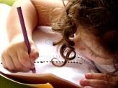  Literacy  In literacy we will continue to practise our handwriting and make sure that we get the size and shape of the letters correct. We will practise writing sentences with a focus on using capital letters and full stops accurately. We will look at the story – Monkey See, Monkey Do! in talk for writing sessions. | 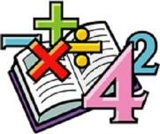  Maths  In maths we will be focusing on place value and addition and subtraction to 20. We will look at and understand numbers 11 – 20, use a number line to 20. We will look at number bonds to 20 and use the knowledge of these in our addition and subtraction calculations. | Science  We will work as scientists to learn about the plants. We will be identifying and describe the basic structure of a variety of common flowering plants, including trees. In our first Science lesson, we will plant seeds and observe them over time. | 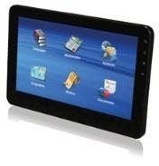  Computing  In Computing this half term, we will be looking at algorithms. We will understand that computers and devices around us use inputs and outputs. We will also understand and be able to explain what decomposition is and know how to debug an algorithm.
Humanities  In History we will be looking at life in the 17th century -  Identifying differences and similarities between ways of life in different periods. We will explain that how people live now is different to how people lived in 1666. We will be able to describe London before, during and after the Great Fire. | Year 1  Overdale Community Primary School  Spring term 1 2024  Big Question: Why was the fire of London called Great? |  | 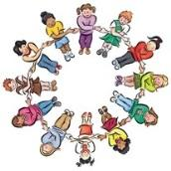  PSHE In PSHE we will be thinking about citizenship and rules. We will look at how to care for others and pets and understand how democracy works.
Art  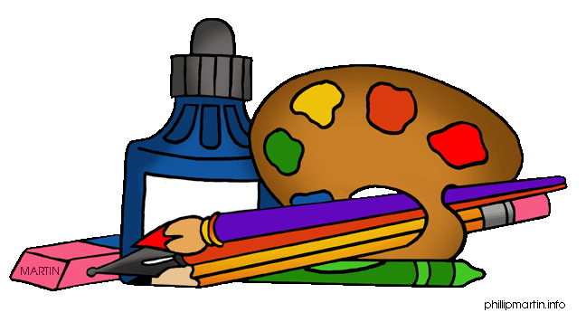  In Art this half term, we will be exploring watercolours. Looking at the work of Paul Klee & Emma Burleigh, we will understand that watercolour is a media that uses water and a pigment. | PE  In PE, our focus this half tern will be on invasion games, in particular our ball skills. We will also have bikeability lessons each week to complement our PE curriculum. | 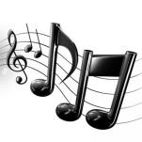  Music In music this half term, we will be supported by our music specialist Mrs Dew where we will look at Tempo. Using our singing voices, we will start to reflect different speeds and build up to performing with a musical instrument. | RE In RE we will look at ‘What it means to belong to a faith community’ We will cover how people in the Christian, Jewish and Muslim faith show that they belong.
Reading: It would be brilliant if you could read with your child at home using their school reading book. Children will also have access to their class Lending Library where they can bring home alternative books to read for pleasure with an adult
Maths: We will be focusing on Place Value and addition and subtraction to 20 – any help at home with this would be great – thank you
Spelling: We will be looking at Phase 5 phonemes words. Please help your child at home to learn the tricky words we will send home.
Homework: A Spring Term 1 sheet will be sent home with your child in their homework book, these activities are optional but should you wish to complete and of these tasks you can record them in their homework books or send through class dojos and we will share in class. A phonics task will also go home each week.

